Ocean Autorouter Setup & Intelligent Automation

Overview
The Autorouter is a standalone web application that integrates with your Ocean site to enable intelligent, rules-based automation for managing eReferral workflows. It uses AI to analyze referrals in real-time and take predefined routing actions—reducing administrative workload, improving response time, and supporting virtual care models.
🧠 How the AI Works
Once configured, the Autorouter monitors events related to eReferrals (e.g., submissions, cancellations, updates) and uses AI to analyze the referral’s contents (form data, patient details, provider info) in real time.
The AI then matches this against user-defined rules and takes routing actions in your Ocean site via secure API connections.

Accessing the Autorouter
The Autorouter is separate from the Ocean Portal and requires a Google or GitHub account to log in.

What You'll Need
- A Google or GitHub account (can be personal, shared, or one-off).
- Your Ocean site number.
- Access to your Ocean Admin Portal to generate OAuth credentials.

Connecting the Autorouter to your Ocean Site
STEP 1: Go to ____ and sign in with a Google or GitHub account.
STEP 2: In the Ocean Portal OAuth Settings, create a Client ID and Secret.

Generating Ocean OAuth Credentials
Systems must send Ocean a site-specific Client ID and secret in order to receive an OAuth token(s) that can be used to submit referral updates for that Ocean site. To generate the Client ID and secret:
- From the Admin Settings page, click Manage Credentials > Manage OAuth Credentials button.
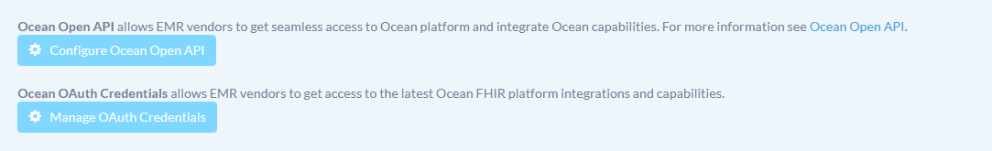
- Add a meaningful name and click the "Add New Credential button."
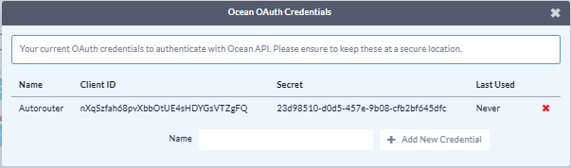
STEP 3: In the Autorouter app’s Site Configuration Page, enter:
• Ocean Site Number
• Client ID
• Client Secret
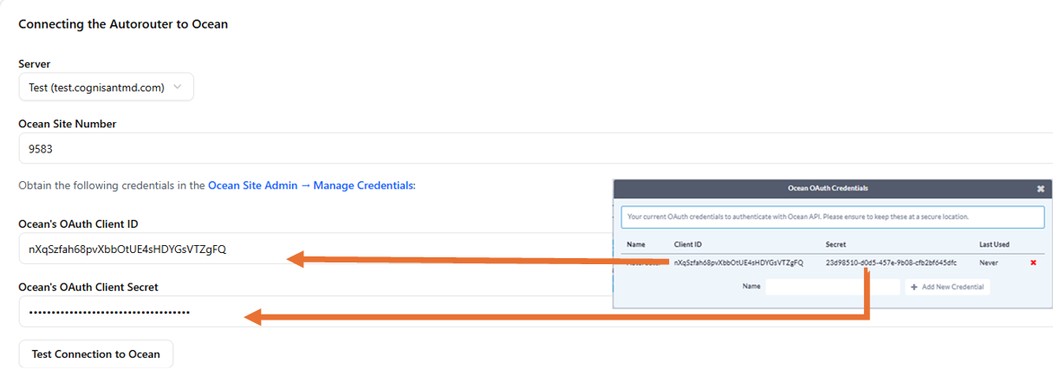
STEP 4: Select the “Test Connection to Ocean” button.
- A success message will be displayed if the connection is working
- If the connection fails, ensure that the “Server” drop down reflects the environment you are connecting to.
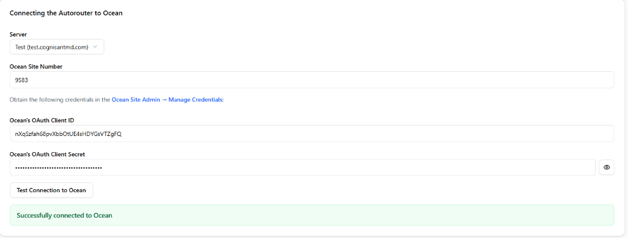

Connecting Your Ocean Site to the Autorouter
STEP 1: From the Admin view in Ocean, navigate to the Integrations page.
STEP 2: Select “register integration”
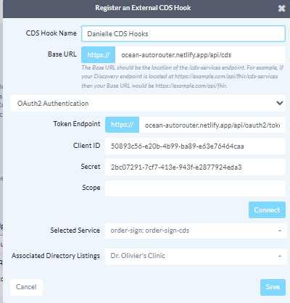
STEP 3: Enter the information provided on the Autorouter page (there are separate tabs for eReferral and CDS hooks integrations)
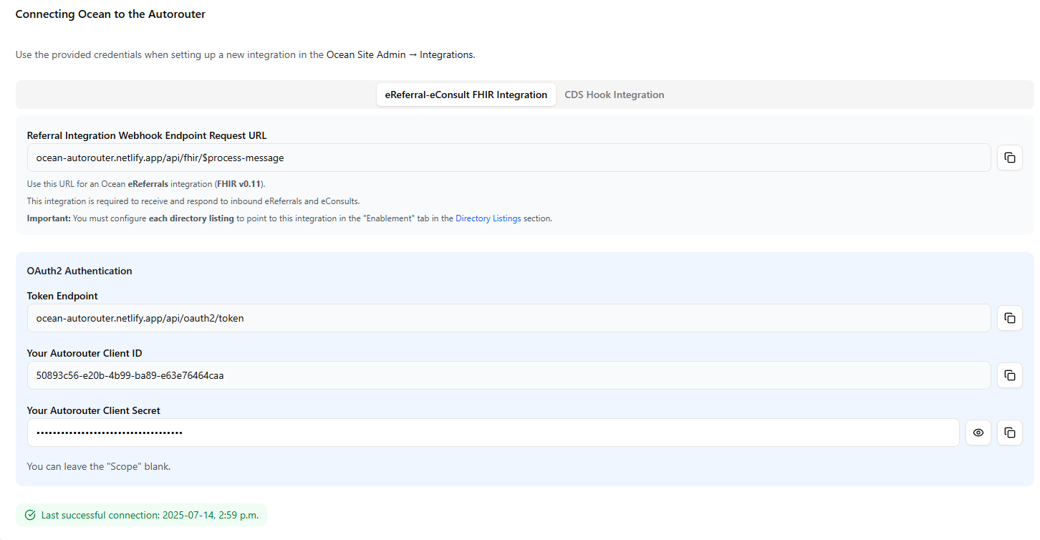
STEP 4: Enable Autorouter integration on the Directory Listing configuration page
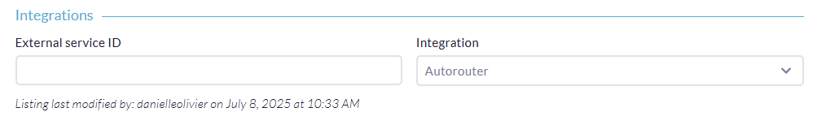
STEP 5: Enable integration with third party applications (e.g. Twillio for SMS, SMTP for email, AI model etc.).
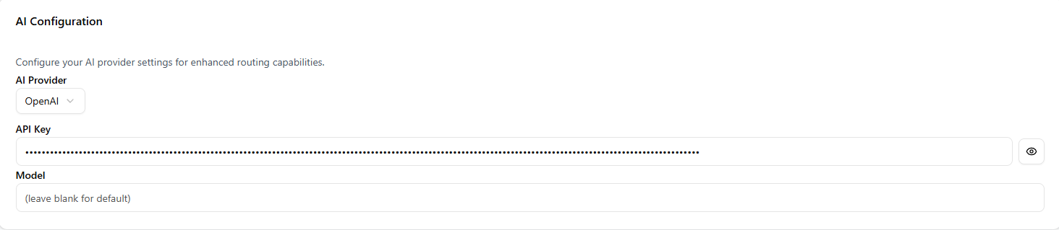

Intelligent Receiving and Routing with Ocean

Routing Rules
⚙️ Routing Rules Overview
The Ocean Autorouter uses rules to automate how eReferrals are handled. Each rule is made up of three components:
- Trigger – what event kicks off the rule
- Action – what should happen in response
- Enablement – which tools must be turned on for the rule to work

Trigger Events
Each rule in the Autorouter listens for a specific event. Common triggers include:
- A referral is about to be submitted
- A new referral is received
- A referral is accepted, declined, or completed
- A referral receives a new message
- A referral is cancelled

You can create rules for one or more of these events and assign specific actions to them.

AI-Driven Actions
Here are the types of automated actions the AI can take on your behalf, based on your rule configurations:

eReferral Analysis
Analyze information in the eReferral, including the referring provider, patient i nformation, referral form entries and the referrer.

It is typically the first step in a rule, used to understand the context of the referral and guide what action(s) should be taken next—such as accepting, forwarding, or sending follow-up communications.
Example:
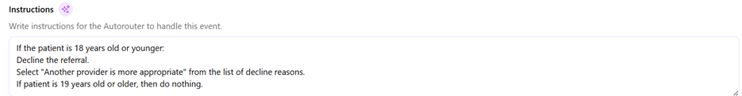

Attachment Analysis
Analyze and summarize the information in the attachment files that are sent with an eReferral.

Typically, a first step used to inform downstream actions based on content in the attachments.

Triage and Assignment
Automatically assign a referral to the most appropriate provider based on information within the eReferral or Forward the referral to a specific directory listing (e.g., central intake, regional hub, or provider group).

Request Management
Accept, decline, or complete a referral automatically when specific conditions are met (e.g., known pathways).

Messaging
Send an Ocean message to the referrer (e.g., clarifications, request for information or instructions). Automatically send an email or SMS message to a specific recipient when conditions are met. Based on the contents of the eRequest, mark it as needing review with a message.

Decision Support
Used before submission of a referral to:
- Warn or block based on form inputs
- Provide context-sensitive guidance using Clinical Decision Support (CDS) integrations E.g., “This test may not be appropriate for the indicated condition.”

eRequest Type Conversion
Convert an eReferral to an eConsult (or vice versa) when conditions suggest a virtual consult is more appropriate.

Metadata Updates
- Change referral health service category
- Add booking instructions
- Add comments to the activity log
- Add AI-generated comments or flag edge cases for manual review

Tool Enablement
For the autorouter to take action on an eRequest, permission must be granted to use certain Ocean tools and features. As such, the third part of rule creation involves tool enablement. An OceanMD staff member can assist with this.
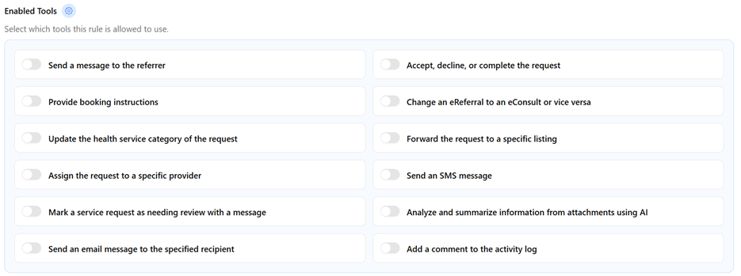

Configuring Routing Rules in the AutoRouter
Once you have completed the steps to connect the AutoRouter to your Ocean site, you can begin rules configuration.
STEP 1: Select the +ADD RULE button
STEP 2: Enter an intuitive name for your rule in Rule Name field
STEP 3: Select the trigger event for the drop down
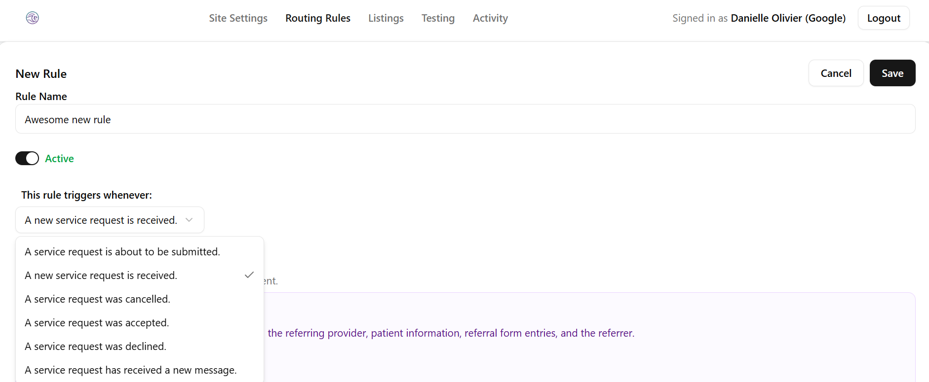

STEP 4: In the instructions text box, write detailed instructions on what you want the rule to do once the trigger event has occurred.
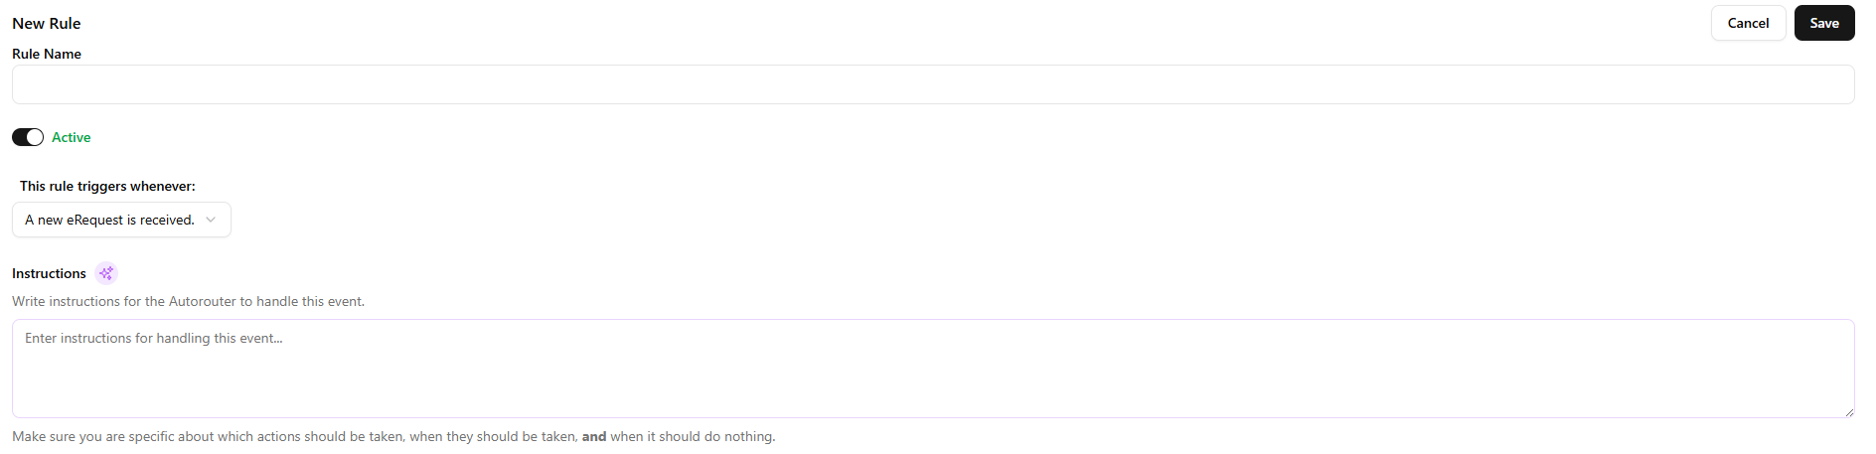
STEP 5: In the Enabled Tools Section, ensure that any tools that may be required to enact the rule you have created are toggled to “on”
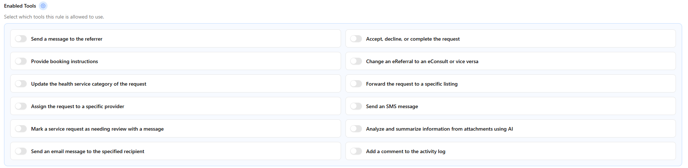

Tips for Building Rules in the Interface
When entering instructions:
- Be specific about keywords or criteria the AI should look for (e.g., referral reason, urgency, specialty).
- Include clear logic paths (e.g., “if x, then do y”).
- Add fallback steps (e.g., “if no match, mark for manual review”).
- Use plain language, as the AI will interpret it with context.

